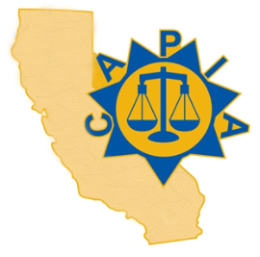 | CALIFORNIA ASSOCIATION OF PROBATION  INSTITUTION ADMINISTRATORS  62nd ANNUAL CAPIA TRAINING CONFERENCE  September 27-30, 2022  THE CLIFFS RESORT / SHELL BEACH, CA

LAST NAME | FIRST NAME | TITLE | FACILITY
STREET ADDRESS | CITY | ZIP | COUNTY
EMAIL ADDRESS | PHONE |  | REGION
North Bay
Central Sac
South

____ | CONFERENCE TUITION – CAPIA MEMBERS  STC Conference Tuition - $350 (STC Funds can be used) / Registration Cost - $25 (Not eligible for STC Funds) Includes Lunch: Tuesday, & Thursday; and Awards Lunch Wednesday plus conference materials | $375.00 | ______
____ | CONFERENCE TUITION – NON-MEMBER  STC Conference Tuition - $350 (STC Funds can be used) / Registration Cost - $25 (Not eligible for STC Funds) / $50 Membership Fee for 2022 (Not eligible for STC Funds) Includes CAPIA Membership for 2022; Lunch: Tuesday & Wednesday & Thursday and Awards Lunch Wednesday, plus conference materials | $425.00 | ______
 | GUEST LUNCH ($100.00 per guest – includes lunch on Tuesday, Wednesday & Thursday)  Lunch: Number of guest ____ x $100.00 |  | ______
TOTAL

SEND COMPLETED FORM AND PAYMENT TO
Southwest Juvenile Hall
Attention: Daniel Castaneda – Division Director
30755-C Auld Rd.
Murrieta, Ca. 92563
Dcastane@RIVCO.ORG
(951)600-6777

Make checks payable to CAPIA Training Conference / CAPIA Tax ID #57-1222421
If you wish to pay by Credit Card Please provide Number below. Please note a 3% Convenience fee will be added.

Credit Card #__________________________________Exp Date:_______________CVV#__________

If payment will be presented at Conference, please note on the registration form.
Conference Registration deadline is September 16, 2022. No refunds will be provided for cancellation after September 16, 2022, however substitutions can be made. Hotel Room Reservation at the Cliffs are available until August 23, 2022.

