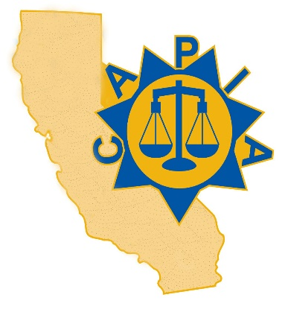

California Association of
Probation Institutions Administrators
65th Annual Conference:
November 4-6, 2025

Rising Above: Empowering Youth, Strengthening Futures

Monday, November 3rd
- 4:00–5:00 PM: Registration

Tuesday, November 4th
- 7:00 - 8:00 AM: Registration
- 8:00 - 8:15 AM: Pledge of Allegiance, Welcome & Announcements
- 8:15 - 8:25 AM: Education and Treatment Alternatives – Diamond Vendor Presentation
- 8:25 - 9:15 AM: CAPIA Regional Meeting Breakout
- 9:25 - 9:35 AM: Correctional Healthcare Partners – Diamond Vendor Presentation
- 9:35 - 9:40 AM: Harm Reduction Solutions – Platinum Vendor Presentation
- 9:40 - 9:45 AM: Wellpath – Platinum Vendor Presentation
- 9:45- 9:50 AM Mandt Systems – Platinum Vendor Presentation
- 10:00 - 12:00 PM: BSCC Session
- 12:00 - 1:00 PM: Lunch
- 1:00 - 3:00 PM: Dr. Shykina Brown: Justice-Based Interdisciplinary Collective Care (JBICC)
- 3:00 - 5:00 PM: OYCR Session

Wednesday, November 5th
- 8:00 - 10:00 AM: Joe Smarro, Addressing Mental Health & Promoting Resiliency Within JI Systems
- 10:00 - 10:10 AM: Break
- 10:10 - 10:15 AM: LifeLab Studios – Platinum Vendor Presentation
- 10:15 - 12:00 PM: SYTF Youth Panel
- 12:00 - 12:45 PM: Lunch
- 12:45 - 1:45 PM: Awards Banquet
- 1:45 - 2:00 PM: Conference Photo (wear department shirts)
- 2:00 - 2:15 PM: Vendor Presentations
- 2:15 - 5:00 PM: Chief’s Panel
- 5:45 - 7:00 PM: First Annual CAPIA Cornhole Cup & Optional Evening Reception

Thursday, November 6th
- 8:00 - 12:00 PM: Mack McGhee & Richard Gentry: Leading with Vision, Purpose, and a Culture of Empowerment & Transformative Leadership by Operating on a High Vibrational Frequency

