ABOUT MONO COUNTY
W
ild by nature, Mono County is a destination that is full of adventure. Set on the eastern slopes of California’s Sierra Nevada mountain range, Mono County is a rare environment of natural contrasts: soaring granite peaks, spacious desert vistas, quiet lakes, bubbling hot springs, cold mountain streams, winter snows, sunny summer skies, rolling sagebrush hills, vibrant wildflower meadows.
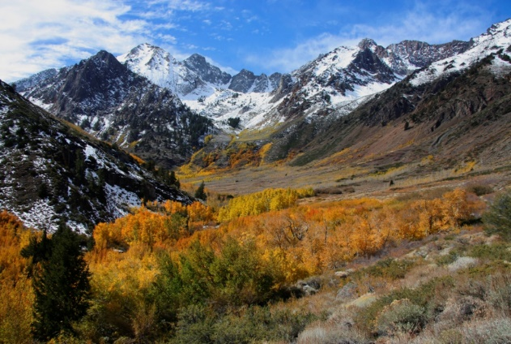
Photo: © Greg Newbry
Best of all, this natural playground is matched with a complete range of amenities and activities making it an ideal place to get away from it all. Enjoy an array of fine shops, restaurants, cafés, snowboard or bike down mountain trails, fish for trout, relax in a soothing hot spring, or paddle a kayak along the shore of an ancient inland sea.
The Town of Mammoth Lakes is the most populated area of Mono County and offers shopping, dining and recreation.
The County Seat is located in picturesque Bridgeport located 360 miles north of LA and 182 miles SE of Sacramento.
The northern areas of the county include Topaz, Coleville and Walker. The southern areas of the county include Crowley Lake, Benton, Mono City, Lee Vining, and Chalfant.
Looking for a lifestyle change with a great quality of life? Mono County is a sparsely populated rural county that offers numerous recreational opportunities for the outdoor enthusiast. Ski Mammoth, fish the Sierra, Hike Yosemite enjoy working where you vacation. An outstanding opportunity exists in the beautiful Eastern Sierra.

BENEFITS: Mono County provides generous benefits, including Cal PERS Safety retirement, medical, dental, vision and 401 deferred compensation. Bilingual pay available.
TO APPLY
County of Mono, CAO/HR
P.O. Box 696, Bridgeport, CA 93517
Telephone: (760) 932-5412
Fax: (760) 932-5411
Email: hr@mono.ca.gov
www.monocounty.ca.gov
Faxes or email will be accepted by the filing date.
SPECIAL NOTE: The provisions of this job bulletin do not constitute an expressed or implied contract. The County of Mono reserves the right to make necessary modifications to the recruitment plan. The physical demands are representative of those that must be met by an employee to successfully perform the essential functions of this job. Reasonable accommodations may be made to enable individuals with disabilities to perform the essential functions. Any questions or comments about the need for accommodation should be directed to HR.

COUNTY OF MONO

INVITES APPLICATIONS FOR

DEPUTY PROBATION OFFICER I/II/III
STARTING HOURLY SALARY (DOE):
Deputy Probation Officer I: $29.81
Deputy Probation Officer II: $32.96
Deputy Probation Officer III: $36.38
Note:
1st application review date:

March 1, 2023

Open Until Filled

Equal Employment Opportunity Employer

the position
U

nder direct supervision, to investigate cases of juvenile delinquency, family court matters, and adult referral for pre-sentence report and recommendation; to supervise a caseload of assigned probationers; and to do related work as required. This is a progression series based on successful completion of qualifications as described within each series (DPO I, DPO II, and DPO III). Essential Duties: Receives adult and juvenile cases assigned by supervisor; conducts an inquiry into the nature of the reported offense or conduct of the client and circumstances surrounding it; interview clients regarding the charges against them; develops family history and background information; develops plan for making regular contacts with the probationer and providing counsel, guidance, and support. Deputy Probation Officer I: This is the entry/training level class for the Probation Officer series. Incumbents work under relatively close supervision performing the more basic assignments that involve the investigation of cases of juvenile delinquency, family court matters, and adult referral for pre-sentence report & recommendation and the supervision of a caseload of assigned probationers. As experience is gained, incumbents perform more independent duties. Incumbents in this classification have Peace Officer status as per 830.5 P.C. The department provides training. On-call duties and after hour assignments are required. Deputy Probation Officer II: This is the journey level class for the Probation Officer class series. The assigned duties are more technical and complex than those assigned to the Deputy Probation Officer I. On-call duties & after hour assignments are required.
Deputy Probation Officer III: This is the advanced working level and lead direction class for the Probation Officer series. Incumbents have responsibility for providing lead direction and coordinating training programs for other staff. They perform the most technical and complex probation casework as well as the full range of probation assignments. Knowledge of: Federal and State laws relating to probation work. Modern probation casework, objectives, principles, & methods including individual & group behavior. Psychology as applied to both juvenile & adult offenders. Community, public and private agencies available for the probationer.
Ability & Willingness to: Apply the principles of adult and juvenile probation work and related court procedures in a variety of situations. Learn the applicable provisions of the Civil, Penal & Welfare and Institutions, Education, Vehicle & Health & Safety Codes. Analyze investigation material & make proper recommendations. Interview clients & elicit necessary information. Prepare and present effective written and oral reports. Establish and maintain effective relationships with probationers and others. Work cooperatively with peace officers, social services and behavioral health agencies.

QUALIFICAtionS
Deputy Probation Officer I:
Minimum Qualifications: Graduation from a four (4) year accredited college or university with a degree.
Applications will be accepted for those in the last year of an accredited college or university.
Deputy Probation Officer II:
Minimum Qualifications: 1-year experience working as a Deputy Probation Officer I with proof of completion of the Probation CORE training and an 832 PC Certificate.
Deputy Probation Officer III:
Two (2) years of professional probation work experience comparable to that of a Deputy Probation Officer II.

SPECIAL REQUIREMENTS: NO FELONY CONVICTIONS; possession of a valid driver’s license and the ability to: qualify for certification to meet California Penal Code Section 832 requirements regarding arrest, search and seizure, and firearms; complete the Board of Corrections course for certified Deputy Probation Officer Core Training and continued compliance with annual training requirements (within one year of hire is a conditional requirement for employment and 40 hrs. of annual training thereafter); obtain a CPR/First Aid Certificate; qualify for training and background which will meet the requirements of California Government Code Sections 1029 and 1031; qualify with a firearm on a quarterly basis.

Physical Requirements & Working Conditions: Sit for extended periods; frequently stand and walk; normal manual dexterity and eye-hand coordination; lift and move object weighing up to 25 pounds; sufficient physical ability and strength to defend self and deal with violent/aggressive individuals; corrected hearing and vision to normal range; verbal communication; use of firearms; and office equipment including computers, telephones, tablets, and copiers. Work is performed in an office and in field environment, frequent contact with staff and public. The incumbent may work nights and may be subject to call-outs. Incumbent may be exposed to bio-hazardous waste.

.

THE EXAM PROCESS

In order for an application to be considered complete, applicants must complete and submit a signed original official County Job Application, and copies of appropriate licenses/certification if appropriate. Failure to do so will be cause for disqualification from the selection process. Resumes are not accepted in lieu of fully completing and submitting the County Job Application and responses to the supplemental questionnaire.
Interviews and a written exam will be scheduled with the applicants successfully meeting the above.
Those applicants moved forward will undergo a psychological, background investigation and physical evaluation.

