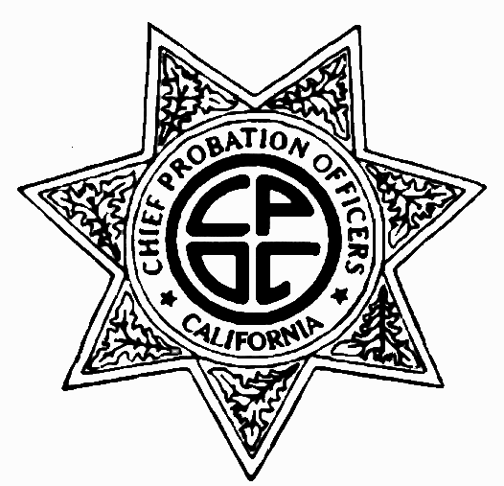Chief Probation Officers of California
1415 L Street, Suite 200
Sacramento, CA 95814
916-447-2762
www.cpoc.org

The Chief Probation Officers of California (CPOC) represents the chiefs in all 58 counties in the State of California. Chief Probation Officers administer juvenile and adult probation programs for offenders sentenced to probation in our communities and must provide for the supervision and treatment programs as ordered by the courts.

2011 CPOC PLATFORM
Stabilize Funding
- Reauthorize Vehicle License Fee (VLF) for local public safety programs, including Juvenile Justice Crime Prevention Act (JJCPA)/Citizens’ Option for Public Safety (COPS) and Juvenile Probation and Camps Funding (JPCF). This funding sunsets on June 30, 2011.
- Ensure sufficient funding for realigned responsibilities such as Youthful Offender Block Grant (YOBG).
- Secure funding for adult probation services under SB 678 funding streams.
- Protect funding for juvenile probation services under Title IV-E.
- Oppose unfunded mandates.

Encourage the Use of Evidence-Based Practices
- Support the increase of state funding for evidence-based practices (EBP) and seek to reinvest the cost savings from EBP implementation back into these programs and services.
- Evidence-based practices are research based proven practices in probation that effectively reduce recidivism through offender accountability, incentives to promote positive change, and supervision intensity and interventions.
- Evidence-based practices in community corrections may include, but are not limited to, risk and needs assessments, targeted interventions and intermediate sanctions, cognitive behavioral treatment methods, skill training with directed practice, increasing positive reinforcement and measuring practices and feedback.

Obtain Funding for Select Offenders
- Support legislation and funding for supervision strategies and evidence-based practices that consider the treatment and service needs of probationers with mental illness in order to improve outcomes for this population.
- Support programs (such as the former Mentally Ill Offender Crime Reduction (MIOCR) grants and Proposition 36 for drug related offenses) that provide mental health, alcohol and drug, and related services for offenders.

Federal Issues
- Support legislation to provide a federal offset for state and local agencies to recover outstanding restitution ordered to the victims of crimes and other delinquent court ordered fines, penalty assessments, and fees associated with criminal or juvenile justice proceedings.
- Support legislation to authorize the county/probation department to collect outstanding victim restitution through the civil process utilizing credit/debit payments after the term of probation has been completed.
- Maximize federal funding opportunities such as Title IV-E and Medi-Cal Administrative Activity (MAA)/Targeted Case Management (TCM).
- Authorize federal reimbursement for the services, supervision, and detention of illegal immigrants.

Please feel free to contact CPOC Legislative Representatives at Warner & Pank, LLC for questions or more information: (916) 443-7318 or www.warnerandpank.com.

